
Provided by Zywave, Inc.

TABLE OF CONTENTS
Introduction 3
Best Practices 4
Work Area 4
Communications 5
Cyber Security Considerations 5
Attire 6
Distractions 6
Self-assessment 7
Breaks 7
Practicality of Telecommuting 7

In an age when more and more positions require duties to be carried out almost exclusively on computers, and where the internet can instantly connect anyone anywhere, many employers, including ABC Company, are offering the option of telecommuting. Telecommuting allows employees to work from home or another alternate location and communicate with their employers electronically.
[Insert customized text or delete altogether: ABC Company trusts its employees and recognizes the value and benefits of telecommuting. Because of all the variables that can affect the success or failure of telecommuting, requests to work from home will be evaluated on a case-by-case basis and approval is up to the discretion of the manager or supervisor. If a work from home request is approved, employees must work out the hours during which they will be online with their manager. Please review the following:
- Manager Sign Off
- Telecommuting Policy Review/Signature
- Cyber Security Considerations
- Actual Telecommuting Agreement
- Home Office Safety Considerations]
In addition to housing all of ABC Company’s policies and guidelines regarding telecommuting, this Work From Home Guide provides you with tips and self-evaluation methods to help you remain engaged and stay on track with your work.
For any questions regarding ABC Company’s telecommuting policy, please contact HR.
- SET A DESIGNATED WORK AREA.
Though this may seem trivial, choosing a spot in your home that is designated for working from home is an important step you can take to set yourself up for success. Choose a spot that you can work from every day that you are working from home. This could be spare bedroom that you’ve turned into a home office, a desk located in the corner of the living room or even the dining room table. However, you should try to stay away from working in your bed or on the couch, as these areas are associated with relaxation in your brain, which could negatively impact your productivity.
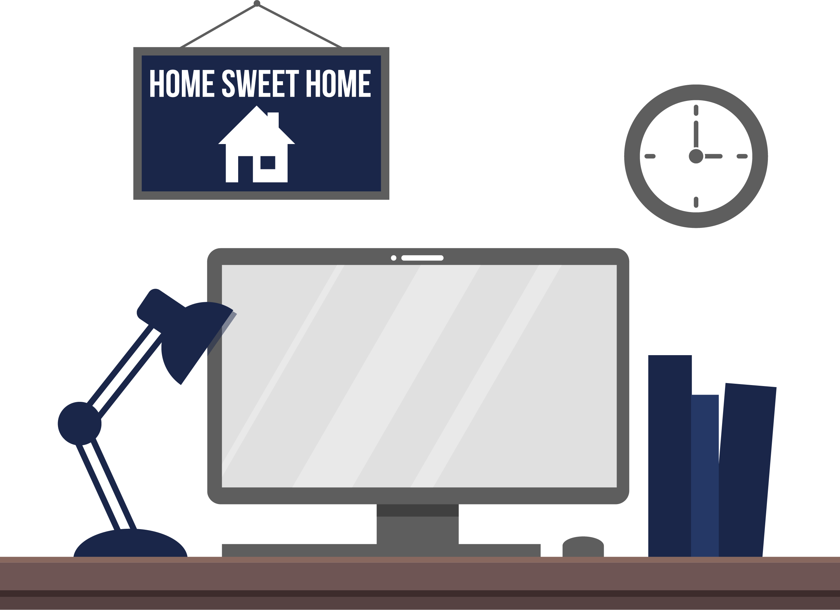
Make sure your workspace functions efficiently for you and your work style. Treat your home work area as you would an office cubicle. Make your workspace a place you enjoy going to each day, an area where you can focus and do your best work.

- PLAN AND TEST COMMUNICATIONS.
To ensure that you aren’t left out of the loop, make sure to schedule regular meetings and communications with your team, supervisors and managers. It can be easy to feel disconnected with what’s going on in the office, so remaining engaged with your co-workers is key. Communications can include the following:


Of course, make sure that your communication method of choice functions properly before you consistently telecommute.

- MAKE SURE YOUR NETWORK AND WORK PROGRAMS ARE PROTECTED.
Telecommuting introduces another set of potential cyber security risks. Make sure you speak with your manager about cyber security and strategies you can use for mitigating the risk of a cyber attack while you are working from your home.
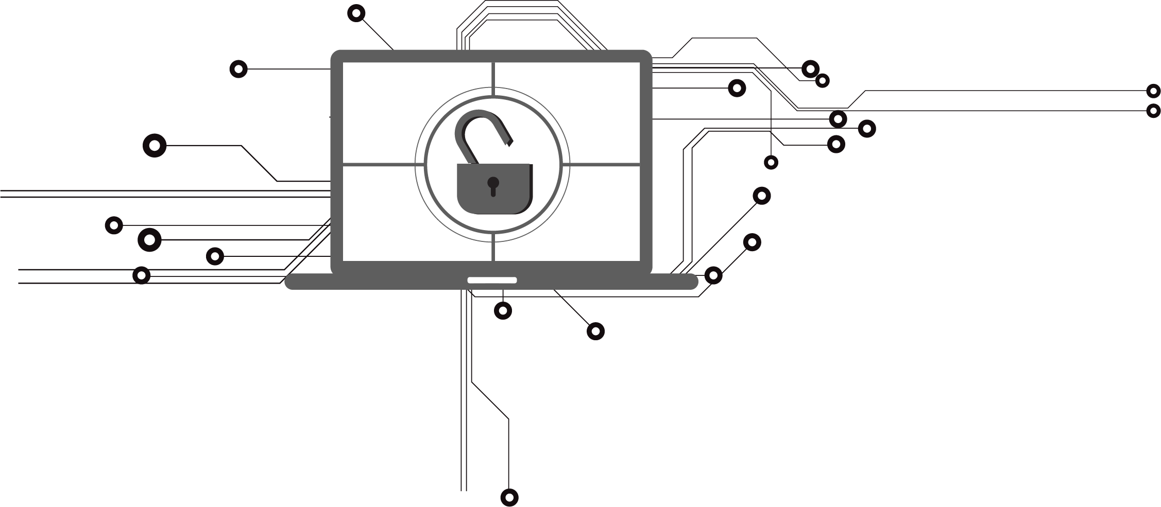


- DRESS LIKE YOU’RE GOING TO WORK IN THE OFFICE.
The way you dress has been proven to affect you psychologically. This means that although it may sound like a great idea to work from home in your pajamas, in reality, it isn’t. While you do not need to dress up in business formal attire if you are working from home, you should take the time to shower, brush your teeth and get ready for the day. Aim to dress in casual—not sloppy—attire.

- AVOID DISTRACTIONS AND STAY ON TASK.
One big challenge of telecommuting is accountability. Without co-workers or managers nearby, it’s easy to become distracted and fall behind on work. Remember that working from home is a privilege, and that it will become apparent if you are not putting in the same effort into your work at home as you did in the office.

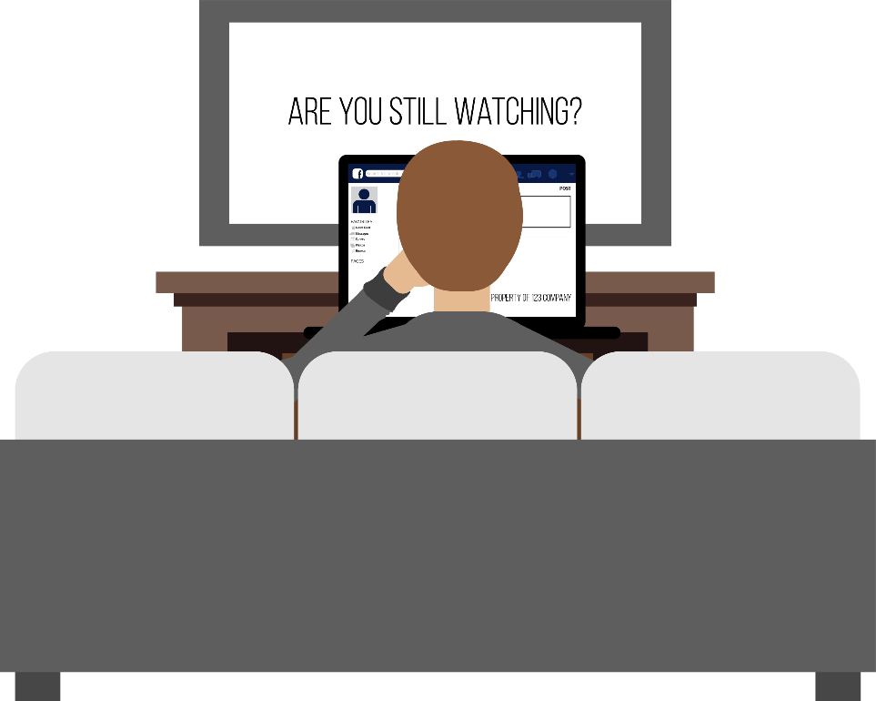
Stay focused on work throughout the day to maintain consistent productivity. Avoid online distractions as well. Limit the time spent on email, social media and websites unrelated to work. Set a timer on your phone or computer if necessary.


- EVALUATE YOURSELF PERIODICALLY.
To ensure that telecommuting is working for you, be sure to conduct self-assessments periodically. Things to include in your assessment could include the following:
- What is working as far as your hours?
- What are you accomplishing in the office versus out of the office?
- Are you meeting all of your deadlines?
- Are you feeling connected with your co-workers?

- REMEMBER TO TAKE BREAKS WHEN YOU NEED TO.
Just like you are encouraged to take breaks while you’re in the office, remember to allow yourself time throughout the day for quick breaks. If you need a short break to gather your thoughts, try walking around the house or down the street, stretching, or making a snack or meal.
If you need to take a longer break or socialize, plan time in your schedule for this. A major advantage of working from home is having flexibility. Before you take an hour or two out of your day, though, make sure to communicate and check with your manager so that you remain compliant with ABC Company’s policies.



- BE HONEST WITH YOURSELF.
Telecommuting is not a viable option for every employee. If you find that working from home is negatively impacting your productivity or making you feel disconnected from your team and your work, speak to your manager.

